**Assignment1-64082**

**Durgaprasad gandi**

**Flash id: 811306331**

**dgandi@kent.edu**

**Question 1:**

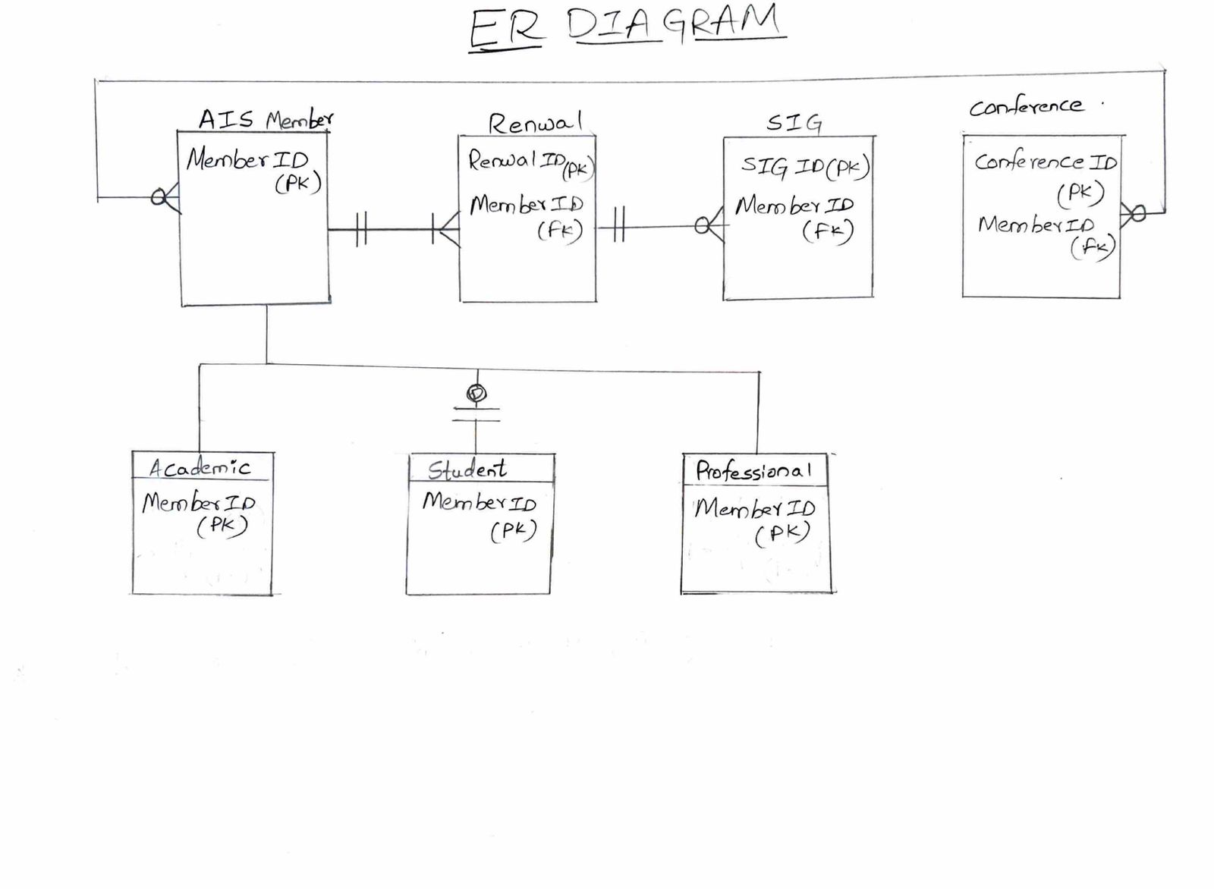

**Assumptions:**

I have assumed attributes MemberID ,Renewal ID,SIG ID,Conference ID,as a primary key so that the attribute MemberID becomes foreign key for Renewal ,SIG ,Conference entities.

**Question-2:**

A.Use the relation above (it is in at least 1NF) to determine ALL functional dependencies that the data suggests MAY be present. Use A→B notation. To be very clear: identify all minimal (atomic) functional dependencies that have data that suggest this functional dependency may exist, even if you think the functional  
dependency would fail a logical test. You should have more blank spaces below than you need. Fill in however many you find.

Session ID Session_Name

SessionID Track

SessionID Duration(Assumption:There should be a start time for a duration)

SessionID Room

SessionID Start_Time

SessionID End_Time

SessionID Nbr_papers

Duration Start_Time

Duration End_Time

Session_Name Track

Track Duration

Track Room

Track Start_Time

Track End_Time

Track Nbr_papers

Duration Nbr_papers(Assumption: Duration can be related with Nbr_papers long hours requires more papers)

**b**. Would any of these functional dependencies cause you to be surprised if it was not removed (i.e., not eliminated as being a legitimate functional dependency) when it is eventually tested logically? Why or why not?If you have more than one option for your response, choose the one that would surprise you the most.  
Be sure to explain your reasoning.

Duration Nbr_papers

* In general the duration will be based on the number of papers or amount of work has to be done.
* The above functional dependency insist that number of papers presented in a session is determined by its duration. For instance, Sessions lasting for 1hour30min have 5papers.

**REASON :** It would be surprising if sessions with the same duration had different number of papers, as it would suggest inconsistency in session Planning.

**c**. Which attribute (if any) could be eliminated without losing any real content, because it seems to be a  
type of redundancy? Briefly explain your reasoning.

Attribute Name Duration

**Reason:**

The attribute Duration could be eliminated because we can calculate or derive the time duration from the attributes Start_Time and End_Time without losing any real content.

**D.** Comment briefly on the suitability of using SessionID as the primary key for the SESSION table in the database. Does it appear to be a good candidate key? Why or why not? Could any problems arise from its use? If so, what are they, and how might you resolve them when designing the database?

SessionID is really important for database since it serves as unique identifier of the table .

Potential issues could arise if SessionID has duplicate Values. Since we don’t have primary key we can get issues when doing logical queries. So, we should select or create new primary key in that case.